***ABSTRACT***

Our project Online Examination system includes registration of Students, storing their details into the system, and they can attend the test for NEET and JEE. Our software has the facility to give a unique id for every student and stores the details of every student automatically. The Online Examination System can be entered using a username and password. It is accessible by an administrator.

The data will be added to the database. The data can be retrieved easily. The interface is very user-friendly. The system incorporates rigorous user authentication measures and employs advanced encryption protocols to ensure the confidentiality and integrity of examination data, addressing concerns related to the high-stakes nature of these competitive exams.

To enhance the effectiveness of preparation, the system integrates adaptive testing algorithms, allowing for personalized and dynamic question sets based on individual performance. So that students can attend their test in their respective dashboard. Flexible exam configuration options, including time limits, randomization of questions and customization based on specific requirements.

**Introduction:**

In The fast-paced world of education, the integration of technology has become imperative to adapt to changing learning paradigms. The Full-Stack Online Examination System represents a pioneering initiative, merging frontend, backend, and database technologies to create a comprehensive platform for online exams and course management.

**Objectives:**

The primary objectives of the system are to provide secure online examinations, efficient course management, and a dynamic user experience. The integration of java, Spring Boot and MongoDB ensures a robust foundation for achieving these goals.

**Problem Statement**:

The traditional method of conducting examinations involves a considerable amount of manual effort, time, and resources. The shift towards online examinations offers numerous advantages, including flexibility, accessibility, and faster result processing. However, several challenges persist, necessitating the development of an advanced online examination system.

Online examinations are susceptible to technical glitches, such as server crashes, internet connectivity issues, and platform instability. Interruptions in the examination process may lead to data loss, frustration among candidates, and a compromised examination experience.

**Benefits of Online Examination System**

**1.User-Friendly Interface:**

Responsive design accommodates various devices, promoting accessibility. Intuitive navigation menus and design elements enhance the overall user experience.

**2.Question Bank Management:**

Support for diverse question types, including multiple-choice, true/false, and essay questions. Tagging and version control features facilitate efficient question bank management.

3.**Exam Configuration:**

Flexible settings allow administrators to customize exams with time limits and attempts. Randomization features minimize cheating risks by shuffling questions and answer choices. Adaptive testing adjusts question difficulty based on participants' responses, optimizing assessment accuracy.

**4.Scalability and Integration:**

Cloud-based infrastructure and load balancing ensure scalability for a large number of users. APIs facilitate seamless integration with existing educational systems. LTI standards ensure compatibility with a variety of learning management systems.

**HARDWARE REQUIREMENTS**:

The most common set of requirements defined by any operating system or software application is the physical computer resources, also known as hardware. A hardware requirements list is often accompanied by a hardware compatibility list (HCL), especially in case of operating systems. An HCL lists tested, compatibility and sometimes incompatible hardware devices for a particular operating system or application. The following sub-sections discuss the various aspects of hardware requirements.

**HARDWARE REQUIREMENTS FOR PRESENT PROJECT:**

PROCESSOR : Intel Core ,i3

RAM : 4GB

**SOFTWARE REQUIREMENTS:**

Software Requirements deal with defining software resource requirements and pre-requisites that need to be installed on a computer to provide optimal functioning of an application. These requirements or pre-requisites are generally not included in the software installation package and need to be installed separately before the software is installed.

**SOFTWARE REQUIREMENTS FOR PRESENT PROJECT:**

OPERATING SYSTEM : Windows 7/ XP/8

FRONT END : HTML, CSS, JAVA SCRIPT.

DATABASE : MySQL

BACKEND: Java , Spring Boot(for connectivity)

**SCHEMA:**

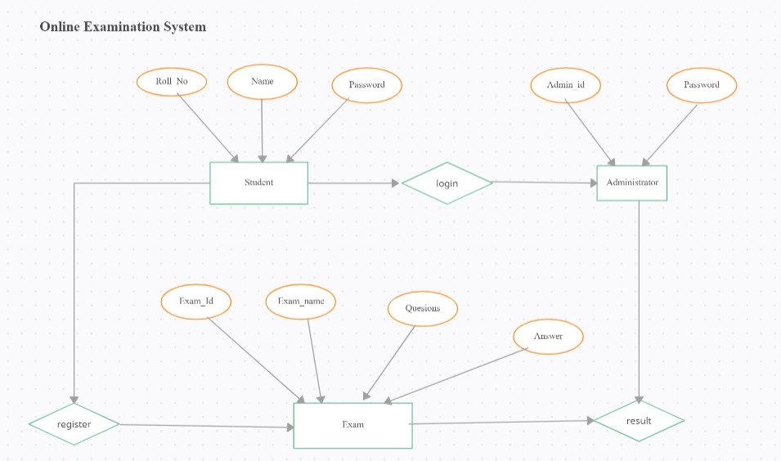

**SAMPLE OUTPUT:**

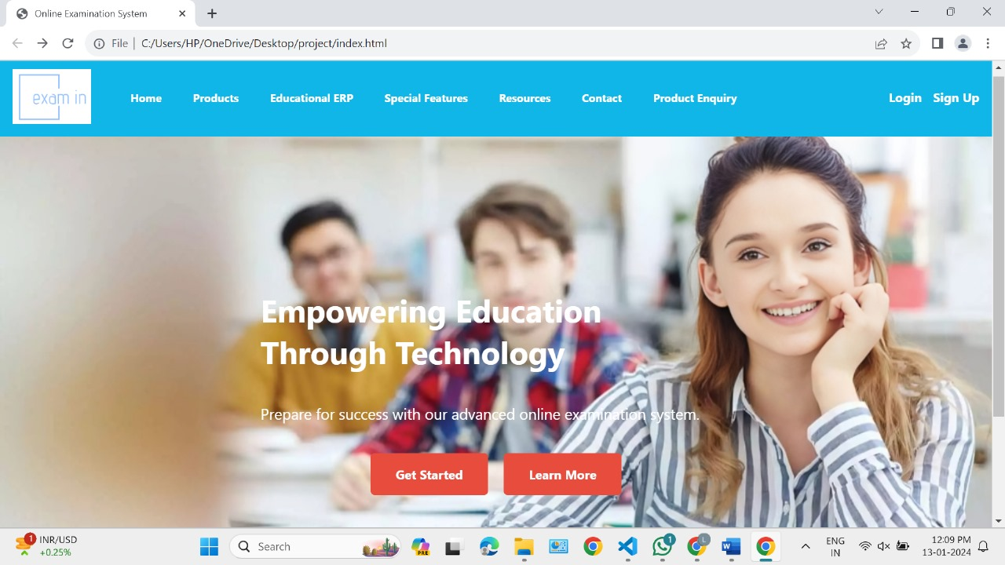

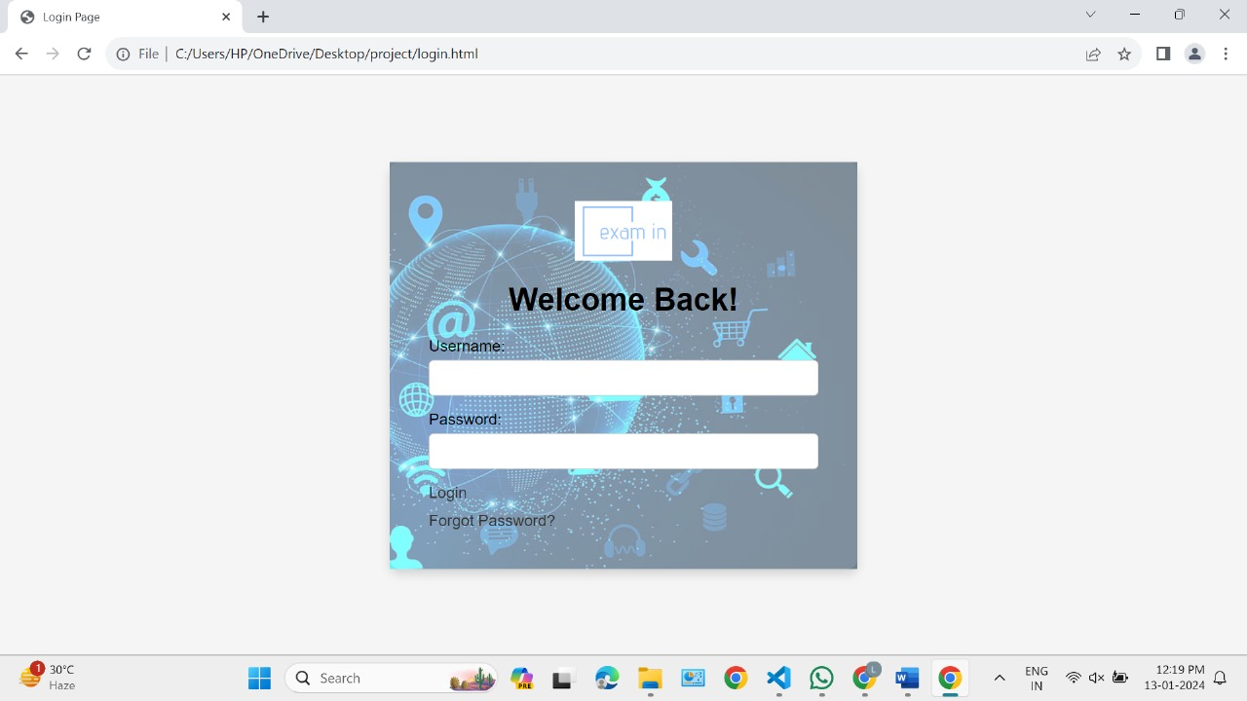

**Conclusion:**

The implementation of an online examination system brings forth a myriad of advantages that significantly contribute to the efficiency, accessibility, and reliability of the examination process. This digital solution not only addresses traditional challenges associated with paper-based exams but also introduces a range of benefits for both institutions and examinees.